**PROJECT REPORT**

# A NOVEL METHOD FOR HANDWRITTEN DIGIT RECOGNITION

**submitted by PNT2022TMID42552**

**YUVASRI D(711019205013) DHIVYA PV(711019205003) ANANDKUMAR S(711019205001)**

**SELVAMARIGANESH(711019205011)**

### TABLE OF CONTENTS

1. **INTRODUCTION**
   1. PROJECT OVERVIEW 1 1.2 PURPOSE

### LITERATURE SURVEY

* 1. EXISTING PROBLEM
  2. REFERENCES
  3. PROBLEM STATEMENT DEFINITION

### IDEATION AND PROPOSED SOLUTION

* 1. EMPATHY MAP CANVAS
  2. IDEATION & BRAINSTORMING
  3. PROPOSED SOLUTION
  4. PROBLEM SOLUTION FIT

### REQUIREMENT ANALYSIS

* 1. FUNCTIONAL REQUIREMENTS
  2. NON- FUNCTIONAL REQUIREMENTS

### .PROJECT DESIGN

* 1. DATA FLOW DIAGRAM
  2. SOLUTION & TECHNICAL ARCHITECTURE
  3. COMPOMENTS AND TECHNOLOGIES
  4. USER STORIES

### .PROJECT PLANNING AND SCHEDULING

* 1. SPRINT PLANNING AND ESTIMATION
  2. SPRINT DELIVERY SCHEDULE
  3. REPORT FROM JIRA

### .CODING & SOLUTIONING

* 1. FEATURE 1
  2. FEATURE 2
  3. FEATURE 3

### TESTING

* 1. TEST CASES
  2. USER ACCEPTANCE TESTING

### RESULTS

* 1. PERFORMANCE METRICS

### ADVANTAGES & DISADVANTAGES

ADVANTAGES DISADVANTAGES

### .CONCLUSION

1. **.FUTURE SCOPE APPENDIX**

SOURCE CODE SCREENSHOTS GITHUB

**CHAPTER 1 INTRODUCTION**

### PROJECT OVERVIEW

Handwritten Digit Recognition is the capacity of a computer to interpret the manually written digits from various sources like messages, bank cheques, papers, pictures, and so forth and in various situations for web-based handwriting recognition on PC tablets, identifying number plates of vehicles, handling bank cheques, digits entered in any forms etc. Machine Learning provides various methods through which human efforts can be reduced in recognizing the manually written digits.

Deep Learning is a machine learning method that trains computers to do what easily falls into place for people: learning through examples. With the utilization of deep learning methods, human attempts can be diminished in perceiving, learning, recognizing and in a lot more regions. Using deep learning, the computer learns to carry out classiﬁcation works from pictures or contents from any document. Deep Learning models can accomplish state-of-art accuracy, beyond the human level performance. The digit recognition model uses large datasets in order to recognize digits from distinctive sources.

### PURPOSE

The main objective was to actualize a pattern characterization method to perceive the handwritten digits provided in the MINIST data set of images of handwritten digits (0‐9). The goal of our work is to create a model that will be able to recognize and classify the handwritten digits from images by using concepts of Convolution Neural Network. Though the goal of our research is to create a model for digit recognition and classiﬁcation, it can also be extended to letters and an individual’s handwriting. With high accuracy rates, the model can solve a lot of real life problems.

The main applications are vehicle license-plate recognition, postal letter-sorting services, Cheque truncation system (CTS) scanning and historical document preservation in archaeology departments, old documents automation in libraries and banks, etc. All these areas deal with large databases and hence demand high recognition accuracy, lesser computational complexity and consistent performance of the recognition system.

## CHAPTER 2 LITERATURE SURVEY

### EXISTING PROBLEM

The fundamental problem with handwritten digit recognition is that handwrittendigits do not always have the same size, width, orientation, and margins since they vary from person to person. People can struggle to read others’ handwriting. The handwritten digits are not always of the same size, width, orientation as they differ from writing of person to person, so the general problem would be while classifying the digits.

Additionally, there would be issues with identifying the numbers because of similarities between numerals like 1 and 7, 5 and 6, 3 and 8, 2 and 5, 2 and 7, etc. Finally, the individuality and variation of each individual's handwriting inﬂuence the structure and appearance of the digits.

### REFERENCES

**Handwritten Digit Recognition using CNN (2019)**

Digit Recognition is a noteworthy and important issue. As the manually written digits are not of a similar size, thickness, position and direction, in this manner, various diﬃculties must be considered to determine the issue of handwritten digit recognition. The uniqueness and assortment in the composition styles of various individuals additionally inﬂuence the example and presence of the digits. It is the strategy for perceiving and arranging transcribed digits. It has a wide range of applications, for example, programmed bank checks, postal locations and tax documents and so on. The aim of this project is to implement a classiﬁcation algorithm to recognize the handwritten digits. The after effects of probably the most broadly utilized Machine Learning Algorithms like SVM, KNN and RFC and with Deep Learning calculation like multilayer CNN utilizing Keras with Theano and Tensorﬂow. Utilizing these, the accuracy of 98.70% utilizing CNN (Keras + Theano) when contrasted with 97.91% utilizing SVM, 96.67% utilizing KNN, 96.89% utilizing RFC was obtained.

### Handwritten Digit Recognition Using Machine And Deep Learning Algorithms (2021)

In this study, they developed three deep and machine learning-based models for handwritten digit recognition using MNIST datasets. In their research, they discovered that CNN produced the most precise outcomes for handwritten digit recognition. This led them to the conclusion that CNN is the most effective 5 solution for all types of prediction issues, including those using picture data. Next, by comparing the execution times of the algorithms, they determined that increasing the number of epochs without changing the conﬁguration of the algorithm is pointless due to the limitation of a certain model, and they discovered that beyond a certain number of epochs, the model begins over-ﬁtting the dataset and provides biased predictions.

### An Eﬃcient And Improved Scheme For Handwritten Digit Recognition Based On Convolutional Neural Network (2019)

This study uses rectiﬁed linear units (ReLU) activation and a convolutional neural network (CNN) that incorporates the Deeplearning4j (DL4J) architecture to recognize handwritten digits. The proposed CNN framework has all the necessary parameters for a high level of MNIST digit classiﬁcation accuracy. The system's training takes into account the time factor as well. The system is also tested by altering the number of CNN layers for additional accuracy veriﬁcation. It is important to note that the CNN architecture consists of two convolutional layers, the ﬁrst with 32 ﬁlters and a 5x5 window size and the second with 64 ﬁlters and a 7x7 window size. In comparison to earlier proposed systems, the experimental ﬁndings show that the proposed CNN architecture for the MNIST dataset demonstrates great performance in terms of time and accuracy. As a result, handwritten numbers are detected with a recognition rate of 99.89% and high precision (99.21%) in a short amount of time.

### Improved Handwritten Digit Recognition Using Convolutional Neural Networks (CNN) (2020)

This paper's primary goal was to enhance handwritten digit recognition ability. To avoid diﬃcult pre-processing, expensive feature extraction, and a complex ensemble (classiﬁer combination) method of a standard recognition system, they examined different convolutional neural network variations. Their current work makes suggestions on the function of several hyper-parameters through thorough evaluation utilizing an MNIST dataset. They also conﬁrmed that optimizing hyper-parameters is crucial for enhancing .CNN architecture performance. With the Adam optimizer for the MNIST database, they were able to surpass many previously published results with a recognition rate of 99.89%. Through the trials, it is made 3 abundantly evident how the performance of handwritten digit recognition is affected by the number of convolutional layers in CNN architecture. According to the paper, evolutionary algorithms can be explored for optimizing convolutional ﬁlter kernel sizes, CNN learning parameters, and the quantity of layers and learning rates.

**A novel method for Handwritten Digit Recognition with Neural Networks(2020)**

Character recognition plays an important role in the modern world. It can solve more complex problems and makes humans’ job easier. An example is handwritten character recognition. This is a system widely used in the world to recognize zip code or postal code for mail sorting. There are different techniques that can be used to recognize handwritten characters. Two techniques researched in this paper are Pattern

Recognition and Artiﬁcial Neural Network (ANN). Both techniques are deﬁned and different methods for each technique is also discussed. Bayesian Decision theory,

Nearest Neighbor rule, and Linear Classiﬁcation or Discrimination is types of methods for Pattern Recognition. Shape recognition, Chinese Character and Handwritten Digit

recognition uses Neural Network to recognize them. Neural Network is used to train and identify written digits. After training and testing, the accuracy rate reached 99%. This accuracy rate is very high.

* 1. **PROBLEM STATEMENT DEFINITION**

The problem statement is to classify handwritten digits. The goal is to take an image of a handwritten digit and determine what that digit and character is. It is easy for the human to perform a task accurately by practicing it repeatedly and memorizing it for the next time. Human brain can process and analyze images easily. Also, recognize the different elements present in the images.

The handwritten digit recognition is the capability of computer applications to recognize the human handwritten digits. It is a hard task for the machine because handwritten digits are not perfect and can be made with many different shapes and sizes. The handwritten digit recognition system is a way to tackle this problem which uses the image of a digit and recognizes the digit present in the image.

Convolutional Neural Network model created using Python library over the MNIST dataset to recognize handwritten digits. Handwriting number recognition is a challenging problem researchers had been research into this area for so long especially in the recent years.

## CHAPTER 3

**IDEATION AND PROPOSED SOLUTION**

### EMPATHY MAP CANVAS

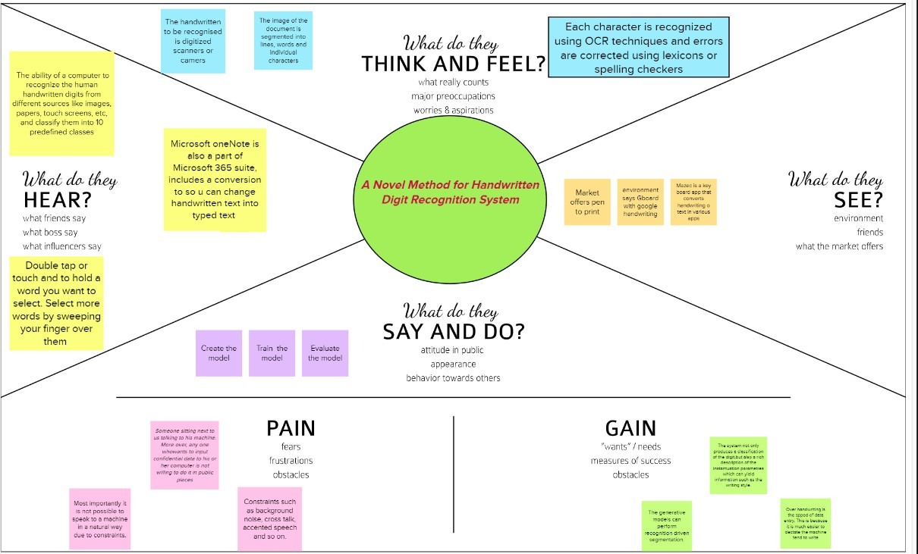

* 1. **IDEATION & BRAINSTORMING**

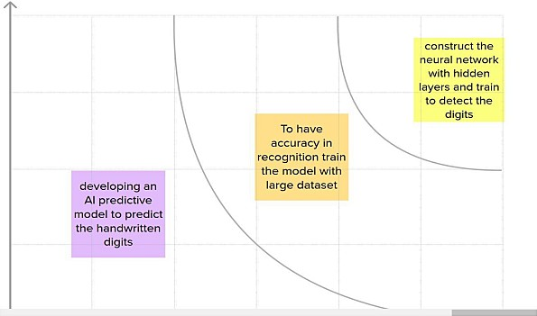

### PROPOSED SOLUTION

|  |  |  |
| --- | --- | --- |
| **SI.NO** | **Parameter** | **Description** |
| 1 | Problem Statement (Problem to be solved | The problem statement aims at developing a novel handwritten recognition system using MLThe handwritten digit recognition system is a way to tackle the problem which uses the image of a digit and recognizes the digit  present in the image |
| 2 | Idea / Solution description | Developing an AI predictive model to predict the handwritten digits and to construct a neural network with hidden layers and train to detect the digits. |
| 3 | Novelty / Uniqueness | The system not only produces a classiﬁcation of the digit but also a rich description of the instantiation parameters which can yield information such as the writing style |
| 4 | Social Impact / Customer Satisfaction | Handwritten digits can be recognized easily without any strenuous efforts. This reduces time and improves productivity for people. |
| 5 | Business Model (Revenue Model) | It is used in the detection of vehicle numbers, banks for reading cheques, post oﬃces for arranging letters, and many other tasks. |
| 6 | Scalability of the Solution | To attain higher performances in the domain of character recognition and pattern recognition dueto its excellent feature extraction and working as best classiﬁer characteristics. There is no limit in the  number of digits that can be recognized |

* 1. **PROBLEM SOLUTION FIT**

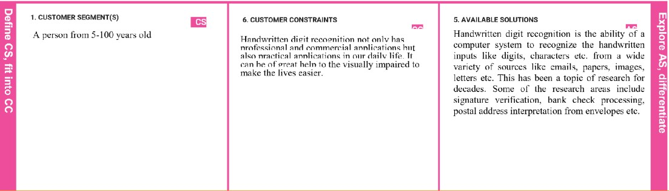

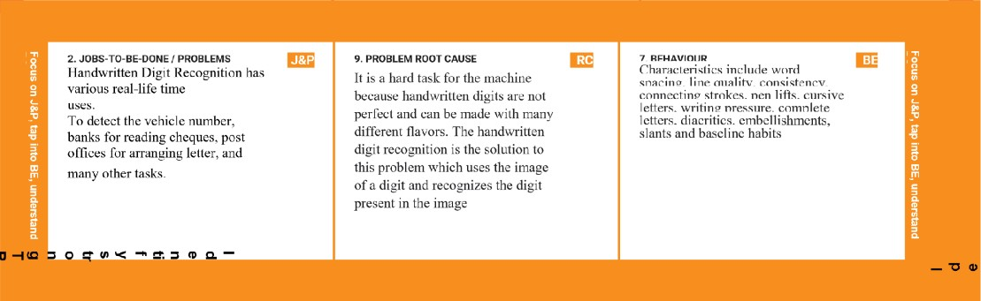

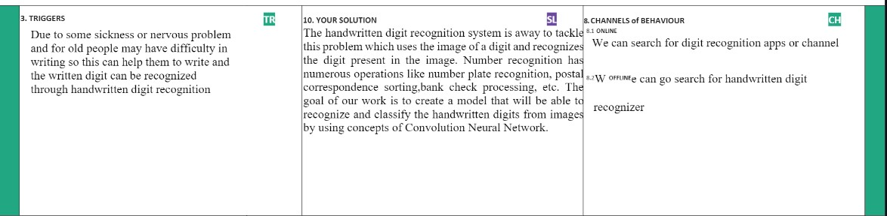

## CHAPTER 4

**REQUIREMENT ANALYSIS**

### FUNCTIONAL REQUIREMENTS

|  |  |  |
| --- | --- | --- |
| **FR No.** | **Functional Requirement (Epic)** | **Sub Requirement (Story / Sub-Task)** |
| **FR-1** | User Registration | Registration through Form Registration through Gmail Registration through LinkedIn |
| **FR-2** | User Conﬁrmation | Conﬁrmation via Email Conﬁrmation via OTP |
| **FR-3** | Upload image | Image upload via ﬁles Image upload via folders Image upload via drive Image upload via web  Image upload via scan/camera |
| **FR-4** | Spelling support | Identiﬁes handwriting of different styles and fonts Spelling check |
| **FR-5** | Translation | Handwritten digits from the image are extracted. Conversion of handwritten digits into machine readable form |
| **FR-6** | Log out | Log out / sign out. |

* 1. **NON-FUNCTIONAL REQUIREMENTS**

|  |  |  |
| --- | --- | --- |
| **NFR.NO** | **Non-Functional Requirement** | **Description** |
| NFR-1 | Usability | The proposed system gives good results for images that contain handwritten text written in different styles, different size and alignment with varying background |
| NFR-2 | Security | Only authorized people can access the system data and modify the database. |
| NFR-3 | Reliability | The Database is frequently updated with handwriting of different styles and size and will rollback when any update fails. |
| NFR-4 | Performance | The proposed system is advantageous as it uses fewer features to train the neural network, which results in faster convergence. |
| NFR-5 | Availability | The system functionality and services are available for use with all operations. |
| NFR-6 | Scalability | The website traﬃc limit must be scalable enough to support 2 lakhs users at a time |

## CHAPTER 5

**PROJECT DESIGN**

### DATA FLOW DIAGRAM

A Data Flow Diagram (DFD) is a traditional visual representation of the information ﬂows within a system. A neat and clear DFD can depict the right amount of the system requirement graphically. It shows how data enters and leaves the system, what changes the information, and where data is stored.

### DFD Level-0

The DFD Level-0 consists of two external entities, the UI and the Output, along with a process, representing the CNN for Digit Recognition .Output is obtained after processing.

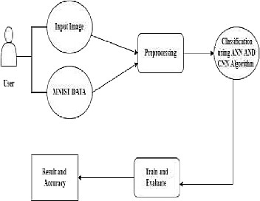

### DFD Level-1

The DFD Level-1 consists of 2 external entities, the GUI and the Output, along with ﬁve process blocks and 2 data stores MNIST data and the Input image store, representing the internal workings of the CNN for Digit Recognition System. Process block imports MNIST data from library. Process block imports the image and process it and sends it to block where regression model is built. It sends objects with probabilities to CNN where weights are updated and multiple layers are built. Block trains and evaluates the model to generate output.

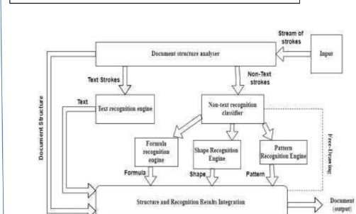

### SOLUTION & TECHNICAL ARCHITECTURE

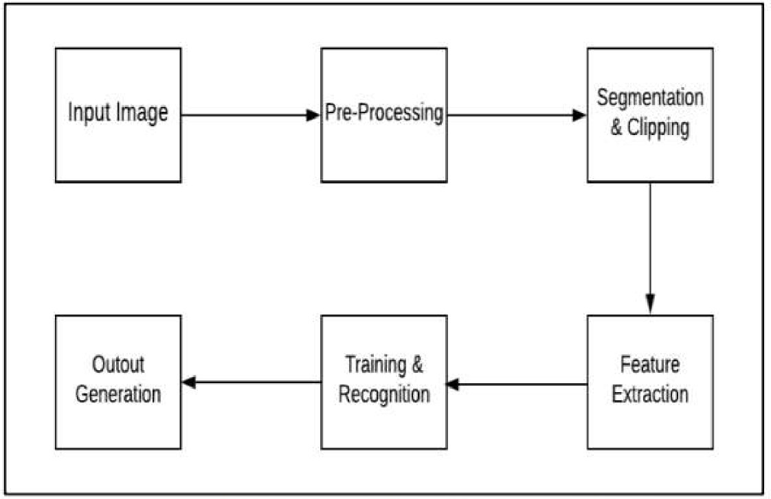

* 1. **COMPONENTS & TECHNOLOGIES:**

|  |  |  |  |
| --- | --- | --- | --- |
| **S.No** | **Component** | **Description** | **Technology** |
| 1 | User Interface | How user interacts with application e.g., Mobile Application | HTML, CSS, JavaScript |
| 2 | Application Logic-1 | Logic for a process in the application | Java / Python |
| 3 | Application Logic-2 | Logic for a process in the application | IBM Watson STT service |
| 4 | Application Logic-3 | Logic for a process in the application | IBM Watson Assistant |
| 5 | Database | Data Type, Conﬁgurations etc. | MySQL, NoSQL, etc |
| 6 | Cloud Database | Database Service on AI in cloud | IBM DB2 |
| 7 | File Storage | File storage requirements | IBM Block Storage or Other Storage Service or local ﬁle system |
| 8 | External API-1 | Purpose of External API used in the application | IBM Weather API, etc. |
| 9 | Internet of Things Model | Purpose of AI Model is for integrating the sensors with a user interface | IBM AI Platform |

|  |  |  |  |
| --- | --- | --- | --- |
| 10 | Machine Learning Model | Purpose of Machine Learning Model | Digit Recognition Model |

## USER STORIES

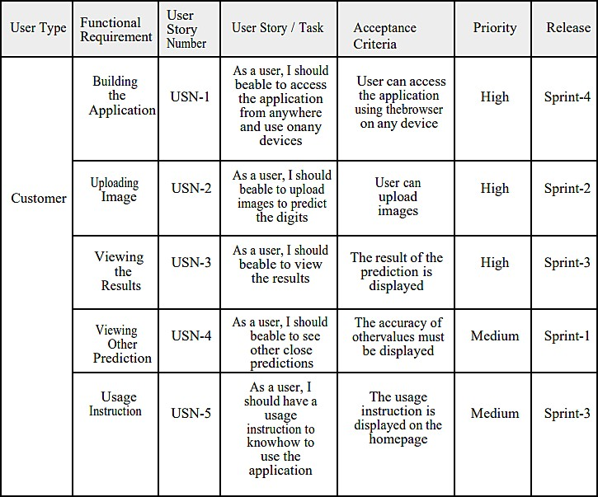

**CHAPTER 6**

## PROJECT PLANNING AND SCHEDULING

### SPRINT PLANNING AND ESTIMATION

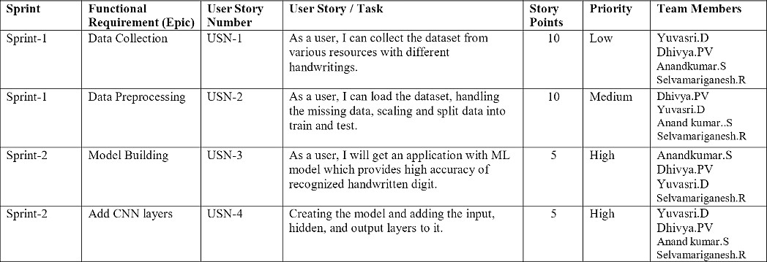

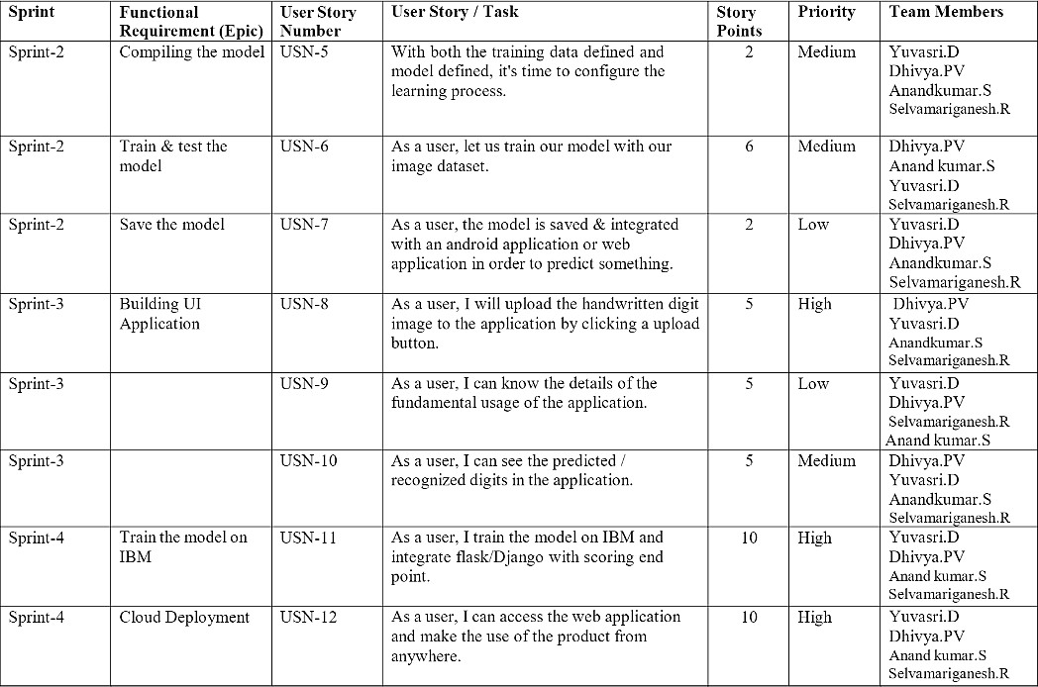

* 1. **SPRINT DELIVERY SCHEDULE**

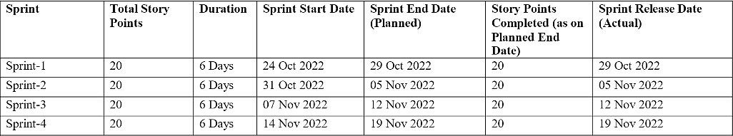

### REPORT FROM JIRA Velocity:

Imagine we have a 10-day sprint duration, and the velocity of the team is 20 (points per sprint). Let’s calculate the team’s average velocity (AV) per iteration unit (story points per day)

Average Velocity = 20 / 6 = 3.33

### Burndown Chart

A burn down chart is a graphical representation of work left to do versus time. It is often used in agile software development methodologies such as Scrum. However, burn down charts can be applied to any project containing measurable progress over time.

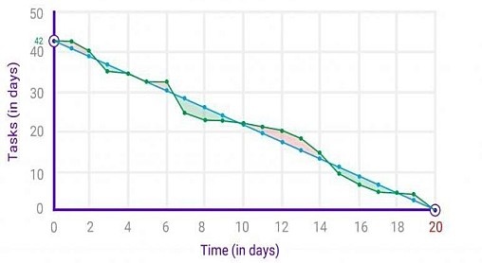

## CHAPTER 7 CODING & SOLUTION

### FEATURE 1 – FLASK FILE UPLOADING

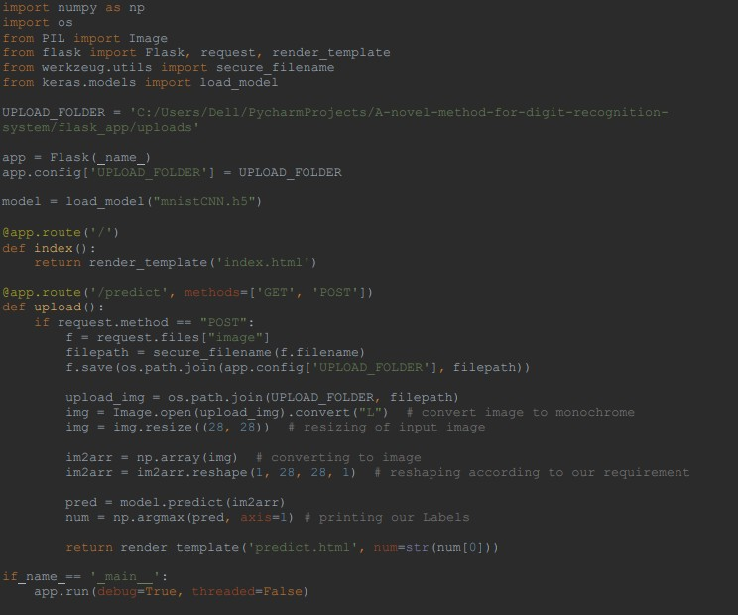Handling ﬁle upload in Flask is very easy. It needs an HTML form with its enctype attribute set to ‘multipart/form-data’, posting the ﬁle to a URL. The URL handler fetches ﬁle from request.ﬁles[] object and saves it to the upload folder.

### FEATURE 2 – UPLOAD IMAGE WITH PREVIEW

A preview refers to a feature that lets you glimpse or view something in part or whole without it being opened. A picture preview would show a small version of the picture and give you a good idea what each picture is without opening each picture it is a useful feature created using JavaScript.

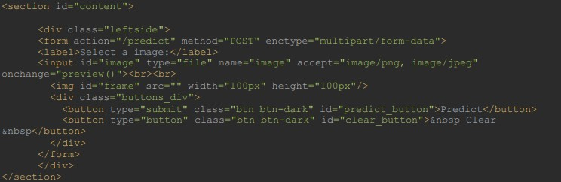

### FEATURE 3 – CLEAR IMAGE

This feature can be used to clear the image if we uploaded a wrong image or if we need to change the image. The clear button clears both the image value and the preview of the image in script tag.

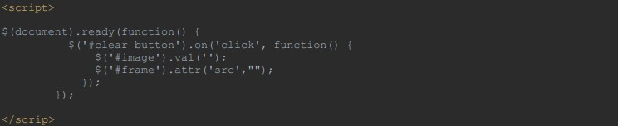

## CHAPTER 8 TESTING

### TEST CASES

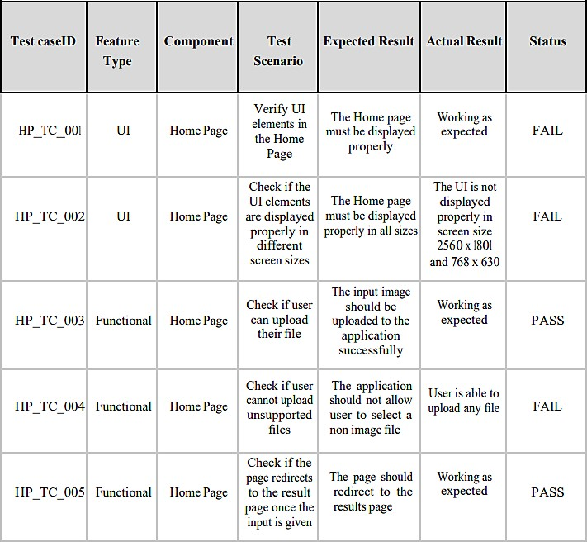

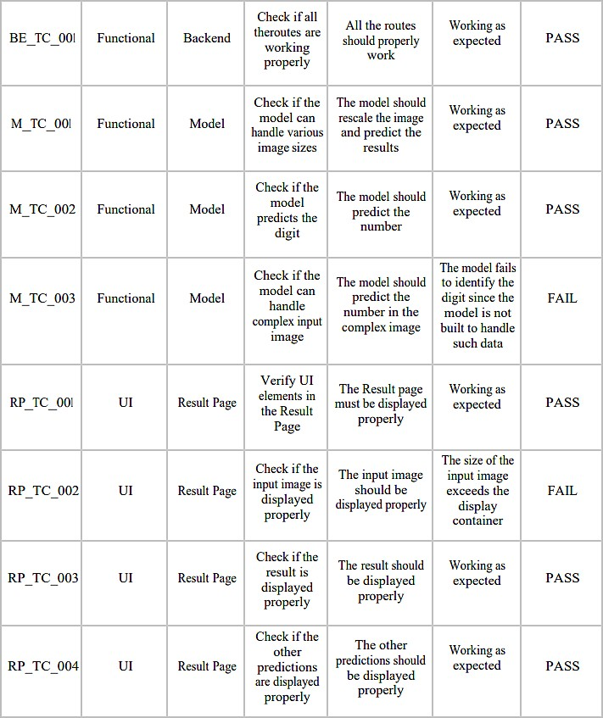

* 1. **USER ACCEPTANCE TESTING**

### DEFECT ANALYSIS

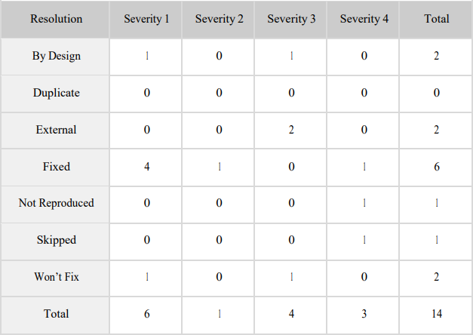

* + 1. **TEST CASE ANALYSIS**

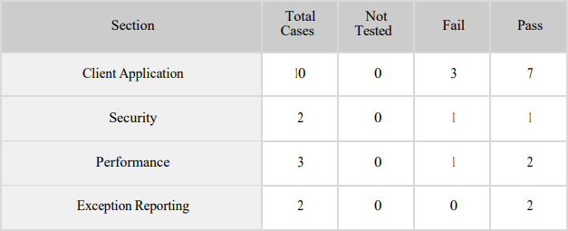

# CHAPTER 9 RESULTS

**9.1 PERFORMANCE METRICS**

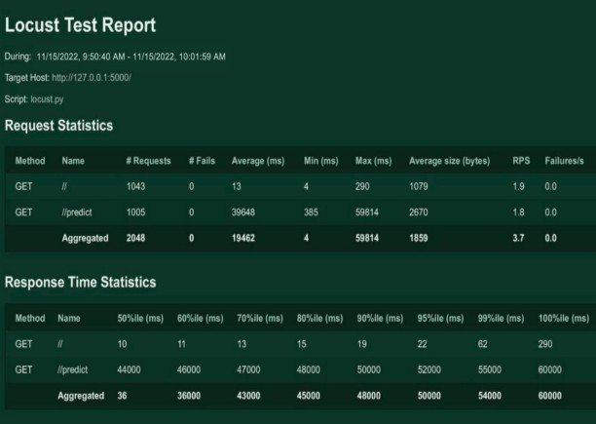

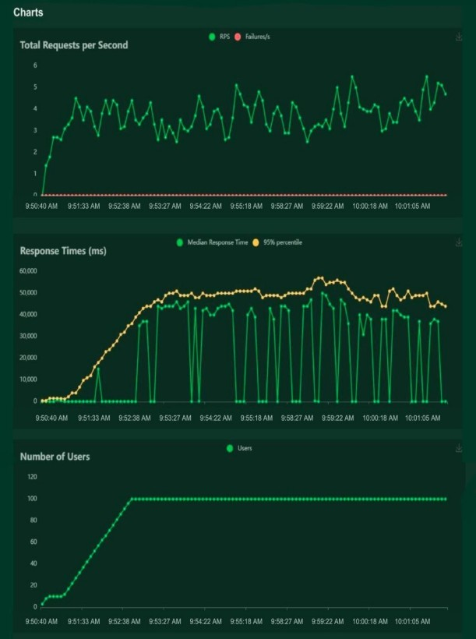

**CHAPTER 10 ADVANTAGES & DISADVANTAGES**

### ADVANTAGES

* Reduces manual work
* More accurate than average human
* Capable of handling a lot of data
* Can be used anywhere from any device
* Neural Network is used to train and identify written digits for greater eﬃciency.
* The accuracy rate is very high.
* Speed of data entry
* It is much easier to dictate the machine than to write
* Easier data retrieval

### DISADVANTAGES

* Cannot handle complex data
* All the data must be in digital format
* Requires a high performance server for faster predictions
* Prone to occasional errors
* There is a wide range of handwriting – good and bad.
* It is tricky for programmers to provide enough examples of how every character might look.
* Customers must try with clear image and neat handwriting to get accuracy in digits.
* Unclear image will not give accurate results

**CHAPTER 11 CONCLUSION**

Convolutional Neural Network (CNN) adds its signiﬁcant improvement to the Manuscript Document Recognition System. This paper tells us the effectiveness of CNNbased classiﬁcation of data and pre-processing methods. Our model clearly sees handwriting and achieves outgoing predictions of up to 82.16% and accurate predictions of up to 69.16%. However the model can be continuously developed using multiple training samples. This will help the model to learn as well as the generalize better. There are many images in the training set that are completely invisible to the human eye.

This project demonstrated a web application that uses machine learning to recognize handwritten numbers. Flask, HTML, CSS, JavaScript, and a few other technologies were used to create this project. The model predicts the handwritten digit using a CNN network. During testing, the model achieved a 99.61% recognition rate. The proposed project is scalable and can easily handle a huge number of users. Since it is a web application, it is compatible with any device that can run a browser.This project is extremely useful in real-world scenarios such as recognizing numberplates of vehicles, processing bank cheque amounts, numeric entries in forms ﬁlled up by hand (tax forms)and so on

Through extensive evaluation using a MNIST dataset, the present work suggests the role of various hyper-parameters. Fine tuning of hyper-parameters is essential in improving the performance of CNN architecture. We achieved a recognition rate of 99.89% with the Adam optimizer for the MNIST database, which is better than all previously reported results. The effect of increasing the number of convolutional layers in CNN architecture on the performance of handwritten digit recognition is clearly presented through the experiments. .

**CHAPTER 12 FUTURE SCOPE**

This project can be enhanced with a great ﬁeld of machine learning and artiﬁcial intelligence. The world can think of a software which can recognize the text from a picture and can show it to the others, for example a shop name detector. Or this project can be extended to a greater concept of all the character sets in the world. This project has not gone for the total English alphabet because there will be more and many more training sets and testing values that the neural network model will not be enough to detect. Think of a AI modeled car sensor going with a direction modeling in the roadside, user shall give only the destination.

All of these enhancement is an application of the texture analysis where advanced image processing, Neural network model for training and advanced AI concepts will come. These applications can be modeled further .As this project is fully done by free and available resources and packages this can be also a limitation of the project. The fund is very important because all machine learning libraries and advanced packages are not available for free. Unless of those the most of the visualizing platforms like on which developers are doing some works like Watson Studio or Aws. These all are mainly paid platforms where a lot of ML projects are going on.

This project is far from complete and there is a lot of room for improvement. Some of the improvements that can be made to this project are as follows:

* Add support to detect from digits multiple images and save the results
* Add support to detect multiple digits
* Improve model to detect digits from complex images
* Add support to different languages to help users from all over the world

This project has endless potential and can always be enhanced to become better. Implementing this concept in the real world will beneﬁt several industries and reduce the workload on many workers, enhancing overall work eﬃciency

**APPENDIX**

### SOURCE CODE

**MODEL CREATION:**

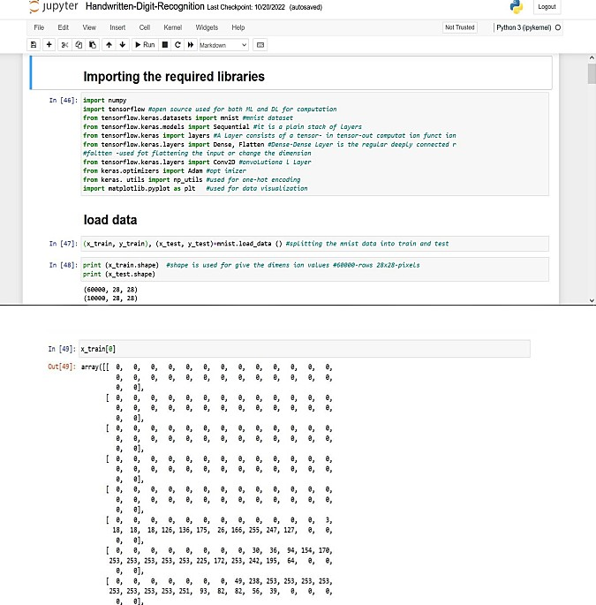

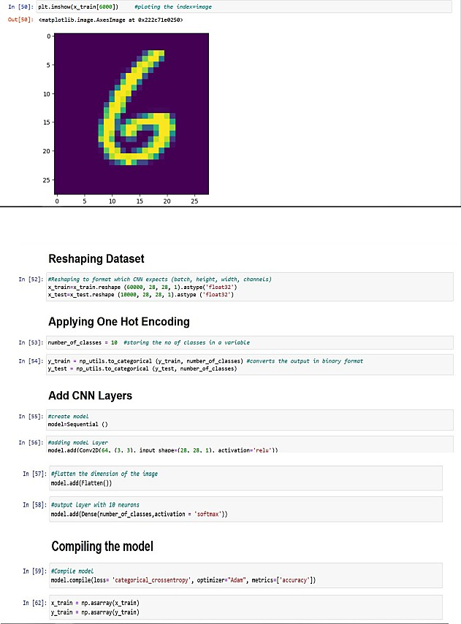

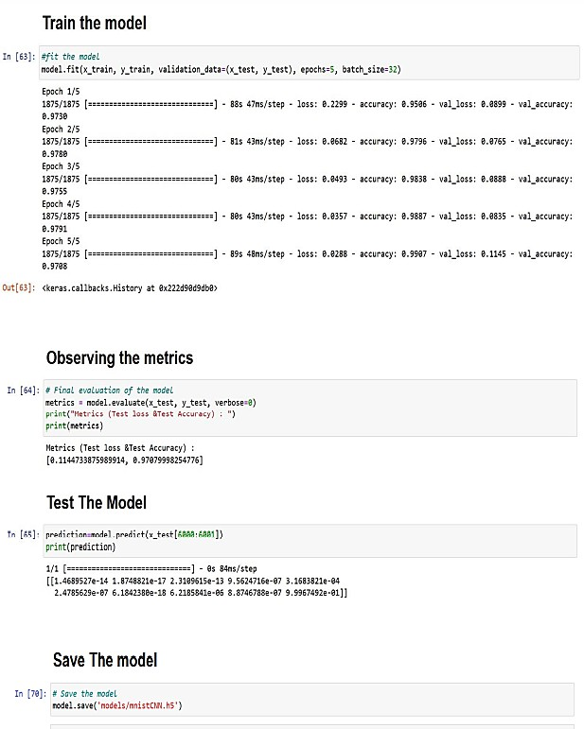

### CNNPREDICTION:

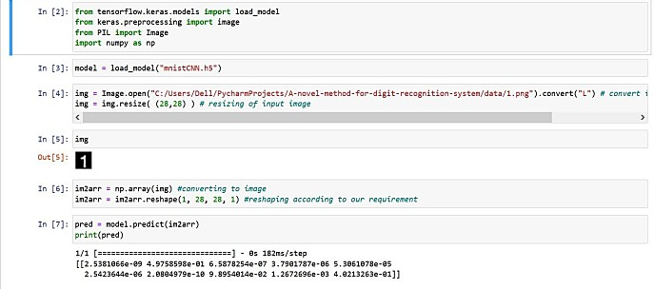

**TRAIN THE MODEL ON IBM:**

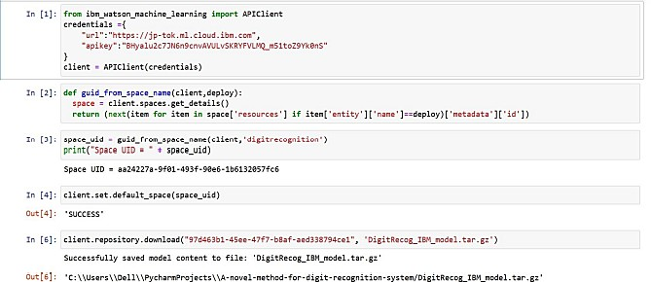

### HOME PAGE(HTML) – index.html

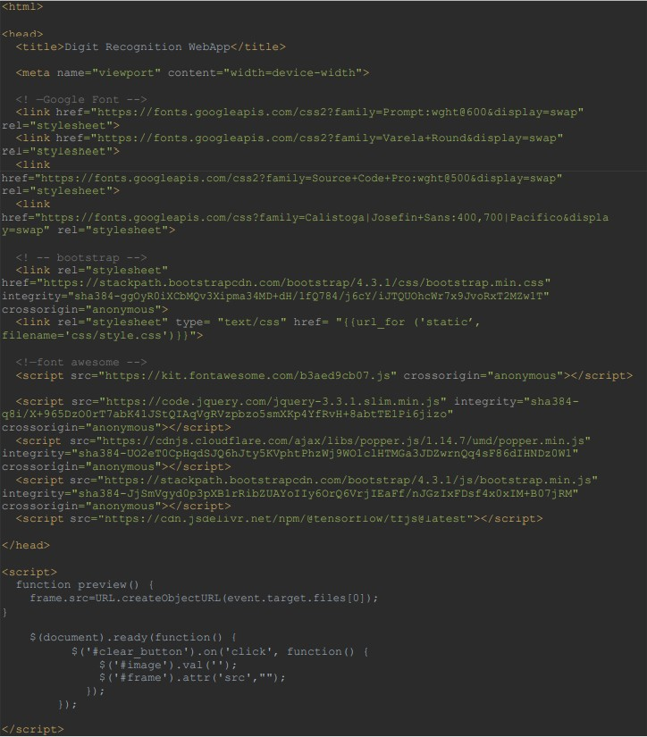

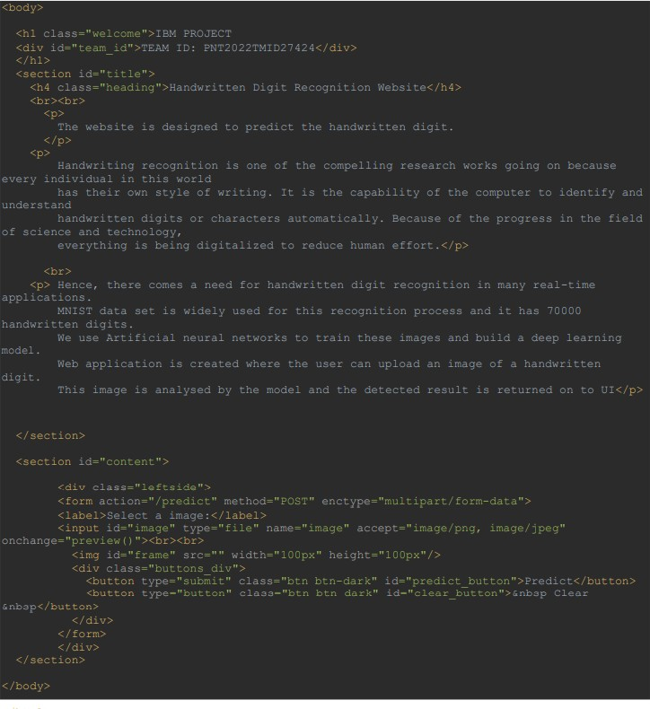

**HOME PAGE(CSS) – style.css**

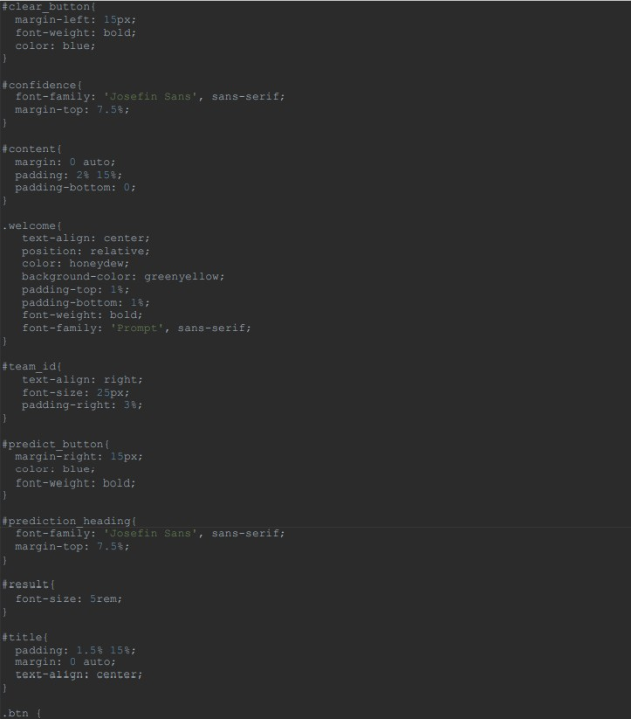

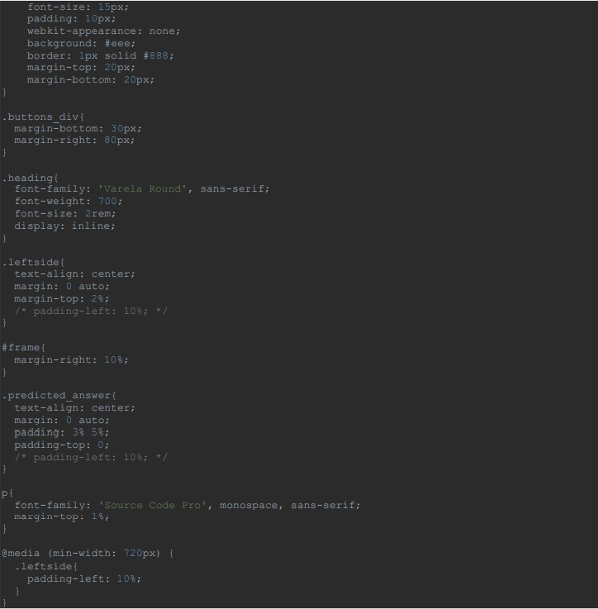

### PREDICT PAGE (HTML) – predict.html

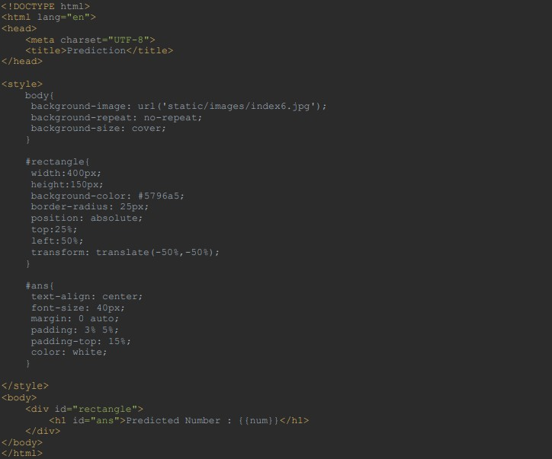

**FLASK APP - app.py**

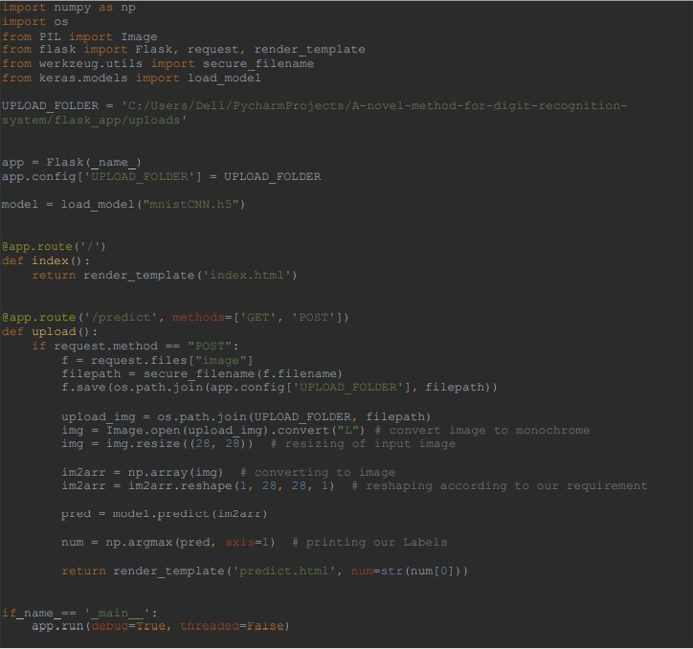

GITHUB LINK :

https://github.com/https://github.com/IBM-EPBL/IBM-Project-4203-1658723667